ERD
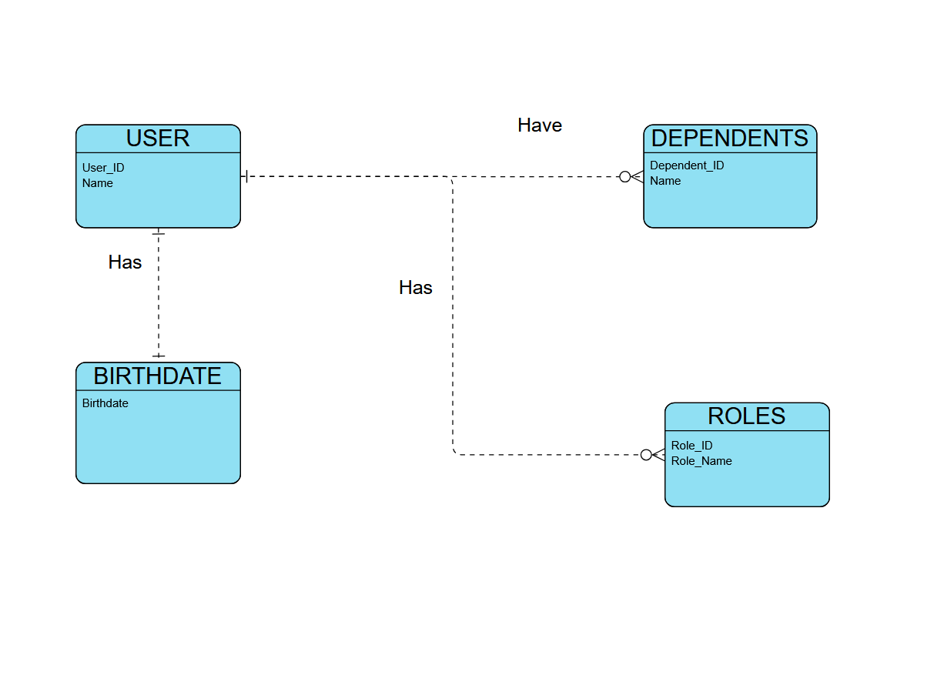

NoSQL
{
"user_id": "user1",
"name": "John Smith",
"birthdate": {
"birthdate_id": "bd456",
"date_of_birth": "1998-07-21"
},
"roles": [
{
"role_id": "r1",
"role_name": "Supervisor"
},
{
"role_id": "r2",
"role_name": "Manager"
}
],
"dependents": [
{
"dependent_id": "d1",
"name": "Jane Smith",
},
{
"dependent_id": "d2",
"name": "Jack Smith",
}
]
}

